Computer Networks Lab 7
The University of Azad Jammu and KashmirCourse : computer networks\
Roll no: 2024-SE-33
Name : Momina Imran
Submitted to : Engr. Asma Javed
Lab :07

Lab Objective:
This experiment explains the basic router access procedure and essential CLI configuration using Cisco Packet Tracer.
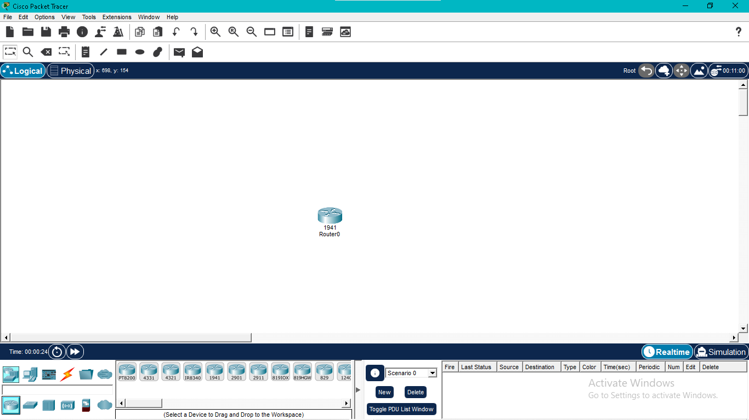

Accessing User EXEC Mode:
The router starts in User EXEC Mode, where users can perform basic monitoring and diagnostic tasks before entering advanced modes.
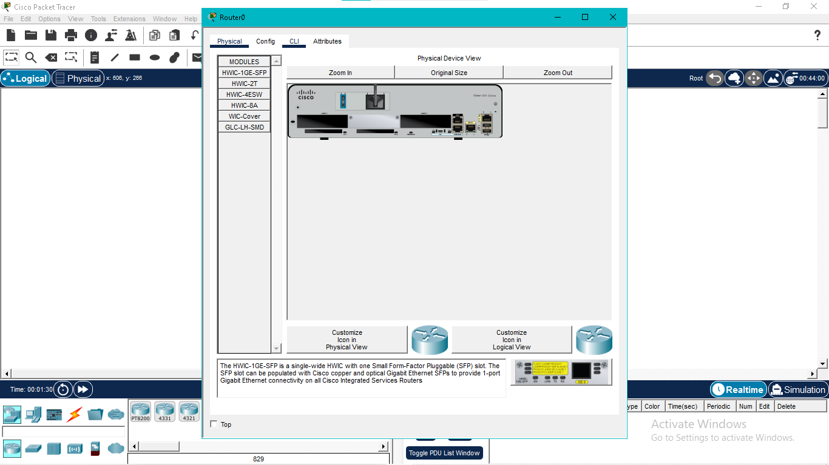

Privileged EXEC Mode:
The 'enable' command switches the router to Privileged EXEC Mode, providing access to administrative commands.
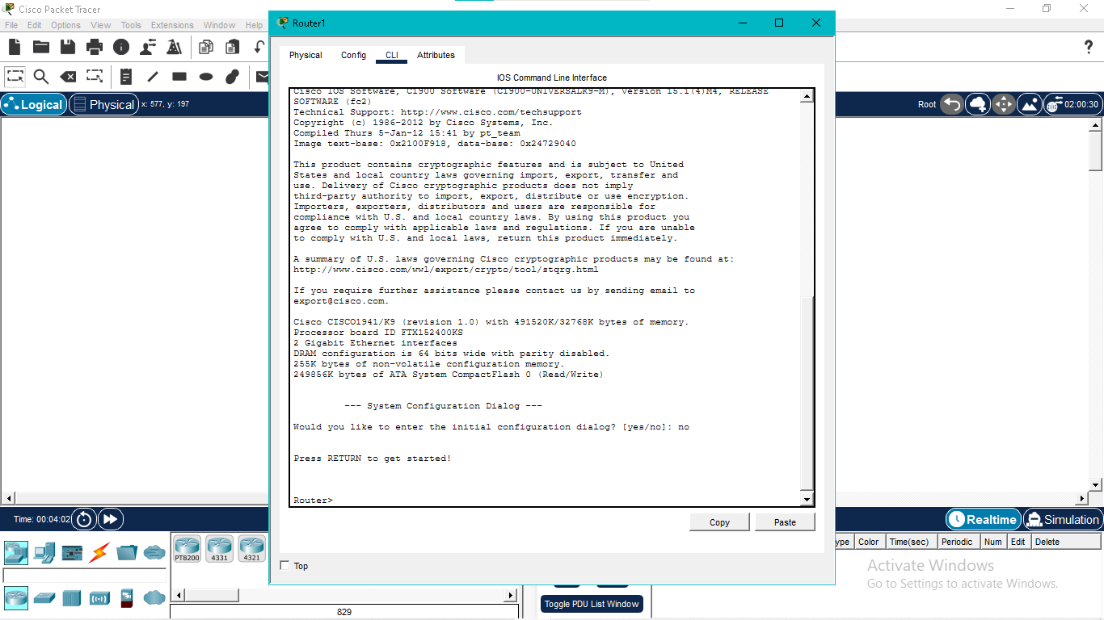

Global Configuration Mode:
The 'configure terminal' command opens Global Configuration Mode, allowing system-wide configuration changes.
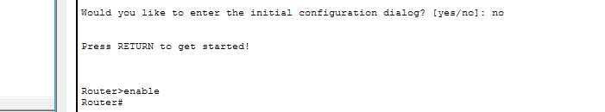

Enable Password:
An enable password is configured to restrict unauthorized access to privileged mode and improve device security.
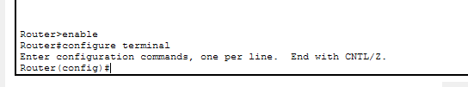

Password Encryption:
The 'service password-encryption' command secures configured passwords by storing them in encrypted form.
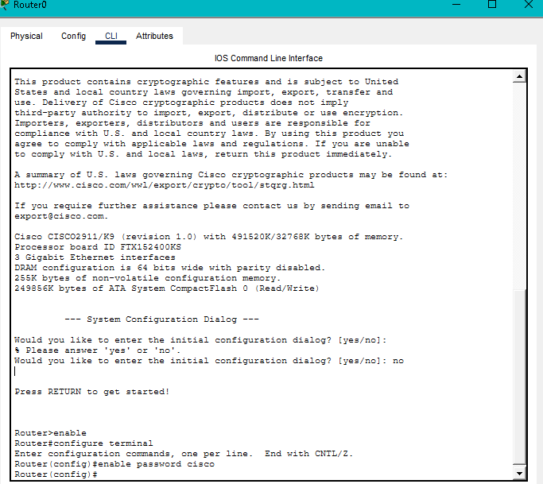

Enable Secret:
The 'enable secret' command creates a stronger encrypted password for privileged mode access and is more secure than the enable password.
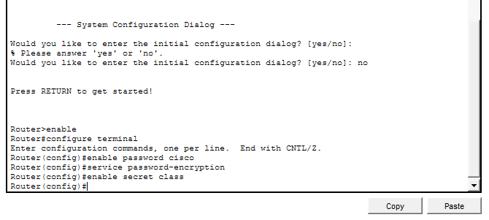

Conclusion:
The router CLI was successfully accessed, secured with passwords, and configured using standard Cisco IOS commands.

